***William Shakespeare’s***

**‘The taming of the shrew’**

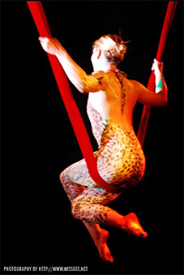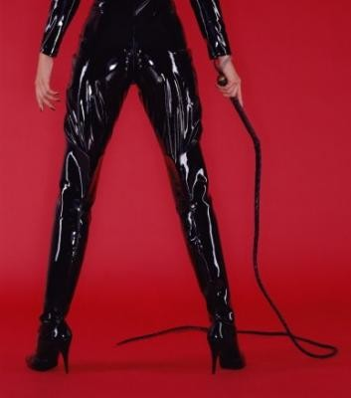

**Preferred slot: week 9, term 2**

**Space: capital studio**

**(full confirmation to be received mon 11/1/10)**

**Contents**

**3 Synopsis**

**5 Characters**

**7 Research**

**8 Production history**

**10 Why ‘The Taming of the Shrew’?**

**13 The vision**

**20 The space: CAPITAL studio**

**22 The team**

**28 The Budget**

**synopsis**

The Taming of the Shrew is initially set up as a ‘play within a play’ when the deceived drunken tinker Sly is tricked into thinking he is a famous and rich lord, and that a group of players have arrived to perform for him. What happens next, however, does not relate back to this opening but once. Lucentio, Gremio and Hortensio are fighting for the love and marriage of the rich Baptista’s youngest daughter, Bianca. However, their problem lies in her father’s decision to prevent her from marriage until her older sister, Katherina, (the ‘shrew) meets a man and is married. The play results in comedy when even Katherina’s own father questions whether it would be possible for anyone to ever fall in love with such a shrew. Lucentio decides to disguise himself as a teacher for Bianca as a way of gaining her company, whilst Hortensio disguises himself as her music teacher for the same reason. Meanwhile, Tranio, Lucentio’s servant, dresses up as Lucentio and begins to discuss with Baptista the possibility of marrying Bianca.

Whilst nobody believes anyone will agree to marry Katherina, Hortensio’s friend Petruchio arrives, and carrying with him an intention to marry a rich woman, agrees to marry Katherina, despite having never seen her. A battle of words is exchanged when he eventually ends up in the company of his wife to be, and Petruchio tells Katherina that she will marry him whether she wants to or not. He tells Baptista that she has consented and the day is set. The wedding scene proves to be a pivotal, key scene within the play. After turning up late to his own wedding and leaving Katherina in fear that she will end up an old maid, Petruchio forces his new wife to leave for his house before the feast has even begun, claiming her as his property to do as he liked with. Once at his home, the process of taming begins, which involves Katherina being starved of food and sleep.

Meanwhile, Lucentio eventually wins Bianca’s heart by wooing her with the Latin he has been teaching her. Hortensio marries a widow instead. Tranio secures Lucentio and Bianca’s marriage by promising a wealthy sum of money behind Lucentio, and says this can be confirmed by his father. To act as Lucentio’s father, Tranio employs an old pedant, however Lucentio and Bianca still decide to elope.

Katherina and Petruchio return to see Baptista and on the way we see how Petruchio has ‘tamed’ his wife to agree with everything he says. On the way they also meet Vincentio, Lucentio’s real father, who goes with them to find Tranio disguised as his son. Eventually Bianca and Lucentio return to report their marriage, which Baptista and Vincentio both agree to.

At the banquet which follows, all are shocked to see how Katherina has transformed. A competition is set by Petruchio to see whose wife is the most ‘obedient’. When Katherina comes to him first, Petruchio rejoices in his successful ‘taming’. The couples rejoice happily over Petruchio’s ‘victory’ and leave the banquet to go to bed, apparently happy in their given genders.

**Characters**

**Baptista** father to Katherina and Bianca and one of the wealthiest men in Padua. Because of the substantial dowries he can provide his daughters with, they become the prey of many suitors. However, he puts a lock on his youngest daughter, Bianca, saying that her older sister must marry before she can.

**Katherina**The ‘shrew’ of the play, Katherina is feisty, aggressive, holds a sharp tongue and a quick temper. Men flock to Bianca for her prettiness but steer clear of Katherina because of her fiery nature. However, the play later reveals her as insecure and jealous of her sister, Bianca, and although she may want us to believe that she will always hold her own and stand up to men, we are left to wonder why she doesn’t refuse Petruchio marriage, even when he says she has no choice.

**Bianca** Bianca is the youngest daughter of Baptista, and is the complete opposite of her sister Katherina. Because of her soft, gentle nature, emphasised by the bad temper of her sister, men flock to her throughout the play; her beauty is enhanced by the prospect of a large dowry. Bianca elopes with Lucentio, but eventually returns and gains approvement from her father.

**Lucentio** Lucentio arrives in Padua from Pisa as a student, along with Tranio and Biondello, his two servants. He falls for Bianca at first sight, and aims to win her by disguising himself as her Latin teacher, and having Tranio dress up as himself to talk Baptista round to their marriage. He eventually wins her love.

**Petruchio** Petruchio is money-minded and agrees to marry Katherina when informed of her dowry and inheritance by his friend Hortensio. Agreeing to marry before they even meet, Petruchio learns of her fiery nature and objection to men, and therefore approaches her with a firm hand which he uses in the process of ‘taming’.

**Hortensio** Hortensio is one of the many suitors to Bianca. It is he that encourages Petruchio to marry Katherina so that her younger sister becomes available. He dresses up as a music teacher for Bianca as a way of wooing her. Hortensio ends up marrying the widow, when he realises he will not win Bianca over Lucentio.

**Tranio** Tranio, as Lucentio’s servant, plays the vital role of disguising himself as Lucentio in an effort to win Baptista round to letting him marry his younger daughter. He also employs the Pedant to play Lucentio’s father and vouch for their wealthy background.

**Grumio** Grumio acts as the fool of the play, as Petruchio’s servant, and often provides the play’s more sinister moments with comic relief.

**Gremio** The third suitor of Bianca. He, like Hortensio, is thwarted in his efforts to win her in marriage.

**Biondello** The second servant of Lucentio.

**Vincentio** Vincentio arrives in Padua and reveals himself as Lucentio’s father, despite the pedant having been employed to act as him.

**Widow** The widow later becomes the wife of Hortensio.

**Pedant** The old Pedant is employed by Tranio to act as Lucentio’s father and assure Baptista that Lucentio has a wealthy inheritance behind him.

**Curtis** Curtis is Petruchio’s main servant at his country house.

**servants/tailors/guests/minstrels** All appear throughout the play when and where necessary.

**Research**

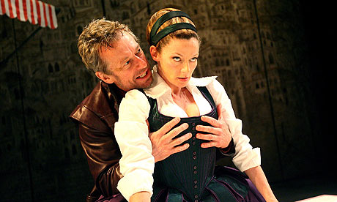**[](http://www.life123.com/bm.pix/carnival-masks.s600x600.jpg)**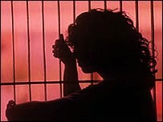

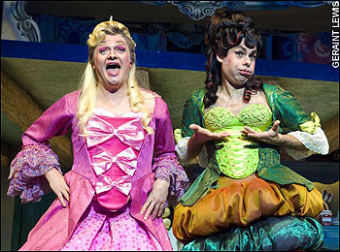



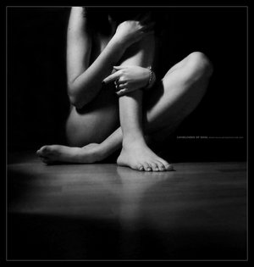



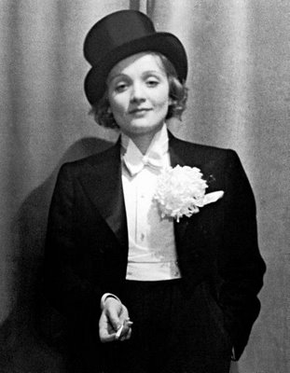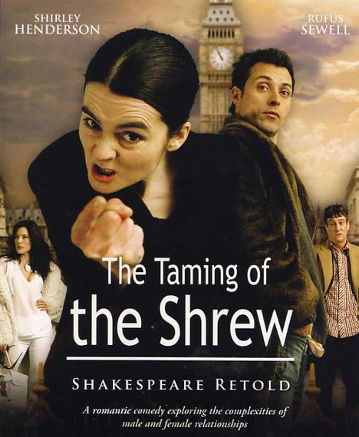



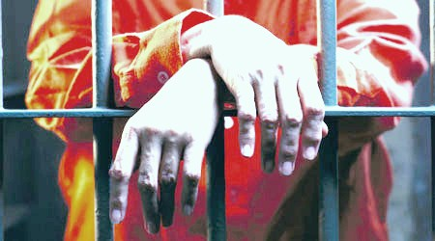

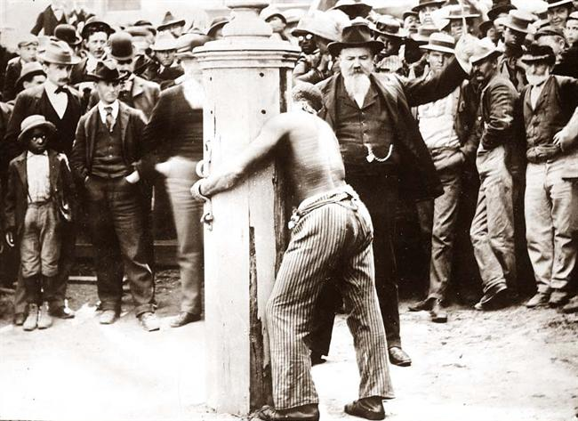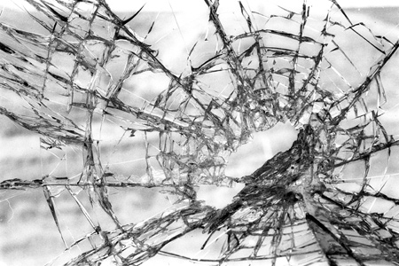

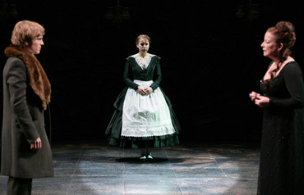

[](http://www.life123.com/bm.pix/carnival-masks.s600x600.jpg)****

**Production history**

*The Taming of the Shrew* was written sometime between 1590 and 1594, and along with *The Comedy of Errors* and *The Two Gentlemen of Verona*, is one of Shakespeare’s earliest comedies. Similar to the other two plays, *Taming* contains a high level of farcical humour; there is kicking, shouting, punching, pinching, slapping galore.

The first recorded performance of the play was in June 1594, with the famous Richard Burbage as Lucentio and Thomas Pope as Petruchio. In 1633, it was performed for Charles I in St. James Court. The most fascinating aspect of its stage history is the fact that from about 1660 until 1844, the play was never performed as Shakespeare wrote it. Restoration playwrights emphasized farce, most notably in John Lacy’s *Sauny the Scot, Or The Taming of the Shrew*. During the Restoration, the play was popular because of the witty battle of the sexes and the general intrigue of the plot. In *Sauny*, the role of Grumio (renamed Sauny) was improved and exaggerated. There were countless adaptations of *Taming* at the time, some of which turned the Sly plot into the entire play.

In 1754, David Garrick adapted *Taming* into *Catharine and Petruchio*, a three-act farce designed to be an afterpiece. Until 1844, this became the only version of *Taming* on both the English and American stage. Garrick cut every plot except for the title characters’, emphasizing the wooing scene, wedding scene, dinner scene, and tailor scene. In the wooing scene, the bawdy jokes (a.k.a. the funniest jokes) were cut, which makes Catharine seem more willing to marry Petruchio.

*Catharine and Petruchio* was still going strong throughout the Victorian era, yet Petruchio gradually became more clownish as Catharine became less shrewish. Typical nineteenth century Kates were incredibly non-shrewish due to the concept of the ideal Victorian woman, which fit more soundly with the acquiescent Kate of the final scene than with the screaming, violent Kate of the first two acts.

In 1844, *The Taming of the Shrew* in its entirety was performed for the first time in 200 years. Benjamin Webster directed and set it in Elizabethan times in order to make it appropriate. Afterwards, many directors mixed Garrick’s adaptation with the original, relying heavily on farce as opposed to language for the comedy. In 1905, E.H. Sothen and Julia Marlowe starred in a production, which much like modern day productions, brought out Petruchio’s affection for Kate and exposed Bianca as a brat who often provokes her sister.

As well as introducing Petruchio’s hidden love for Kate, modern productions have also given us new ways of looking at the shrew. In the last fifty years, 'Kates' have either found cunning ways to control Petruchio, or have decided to oblige out of love. Many times, Kate appears to enjoy playing the game with her husband, and her final speech is given with a wink towards the audience.

The key to creating an interesting production of this hilarious play seems to lie in an important balance between the farce of the actions and the humanity of the characters. Farce distances the audience from the play (which can be a good thing when Petruchio is beating the living daylights out of Grumio), but many directors have taken it too far and turned the play into a senseless spectacle. A Stratford production in 1954 had Kate and Petruchio fall in love at first sight, portraying the rest of the bickering as a game, which brings out the theme of posing, or disguising. Many modern directors, such as Trevor Nunn, have explored the idea of reality versus theatrical illusion, which makes the Sly subplot (usually left out) completely necessary, an approach which seems in many ways true to Shakespeare. *The Taming of the Shrew* was one of The Bard’s earliest plays and it is characteristic of him to be testing the boundaries between theatre and reality.

**Why ‘the taming of the shrew’?**

The taming of the shrew is a play that is, in our team’s opinion, not performed enough. Michael Billington reportedly asked the question ‘is there any reason to revive a play that seems totally offensive to our stage and our society?’ in answer to this, we can reply with the provision of examples of many other plays which may be morally offensive and inapplicable to today’s society. For example, the recent success of All’s Well that ends Well shows how the theatre audience of the 21st century is able to fully distinguish between the attributes of a society that is long gone, and those which are still present. The ‘bed trick’ within All’s Well and the imposed marriage upon Bertram may not, as it stands, be so wholly acceptable in a contemporary context, but none-the-less we are able to laugh at it even more so because of the knowledge we have of it being completely unrealistic and unlikely to ever happen to us ourselves. Although The Taming of the Shrew may show up the qualities of both men and women in an unfavourable light, we will use the comedy, the farce, and the circus versus prison type concept as a way of evading the seriousness that Billington might have been approaching the play with. The play is comical and serious, funny and dark, farcical and sinister, and all of these contrasts serve in demonstrating the importance of the playwright’s vision and necessity for the play: to demonstrate the differences between men and women in his own context. By providing the stage with a version of this play, audiences can consider the differences not only in gender but also in attitudes towards men and women in the 16th and 17th centuries compared to today. In addition to this the play provides us with an opportunity to not only do a play that is rarely seen on stage, but also to perform a play that is not context or time period specific. With the use of the abstract and surreal, we can use the themes of the play, such as hell, the animal, the man versus the woman, power, and so on, as a way of distinguishing the need for a specific era to set the play in. by doing so, we also reignite within the play the idea of a dystopia, which in turn diminishes the restriction of the play being purely about gender roles, and instead reinforcing the ideas of power, control and dominance, and the effect it can have on the world you exist in. With regards to today’s society, the idea of power, wealth and economic transaction become immediately apparent and relevant to a 21st century context, while the ideas of gender roles immediately transfer to being functional to the expression of such ideas.

Over all of this, the ideas of gender roles, power and money and the idea of marriage being an economical and financial transaction teach us much about the qualities and values of Shakespearean love and marriage; this being something we are far from being alien from with regards to his other plays.

The Taming can also be seen as a problem play as well as a comedy, because of the issues it raises, and the way in which it approaches issues that may seem offensive to any society and time period, and not just ours. In this way, it would be beneficial for educational debate and research. The play’s importance and applicability to any context can be seen from the adaptations of the play into film and musical, for example ‘Kiss me Kate’ and ’10 Things I Hate about you’. In this way, we can identify the importance of the play and its themes in every environment, but yet it is rarely carried through in its original space; on the stage. In this way, however, one is able to see the malleability of the production and how it is completely open to interpretation; this is a fabulous reason alone to choose this play, as it really seems that going ‘too far’ with it is highly unlikely. It would be fantastic to have something new, exciting and fresh on stage that completely turns the norm on its head and provides the Warwick drama scene with something vivid and memorable.

The play will also be of an advantage to us as not only will it allow a tight group of actors to work well together and become more interactive with each other vocally and spatially, but also physically. The play will involve much gender exploration as well as physical exploration, and the play requires a lot of interaction with one’s own body and spatial awareness as well as how this relates to that of other characters on stage. The play often relates certain characters to the animal and in this way the production will allow the actors to engage with their movement and spatial creativity as much as possible. In this way, it is a great idea to perform this play as rarely a Shakespeare production will allow such abstract performance as well as a complete subversion of norms. In educational terms, the play will not, as said previously, merely allow discussion to form concerning the changing attitudes towards gender and marriage and the everlasting dilemma of power and control, but will also allow a class or audience to look at the play’s language very closely and identify with how Shakespeare was asking his actors to use their bodies to challenge fellow characters, as well as push their own bodies and persona’s to their ultimate limit. Physical theatre will also come under education, as much can be approached within the play regarding the use of space and an actor’s response to the space they are in.

**Vision**

The Taming of the Shrew contains role reversals, gender issues, violence, sexual repression and aggression, animalistic and devilish behaviour, as well as complete farcical moments where the play may take any audience member by complete surprise. Our concept will involve the subverting of all norms that we see today in 21st century society. This will involve the idea of ‘taming’ a woman, a woman being completely subversive to a man, and a man behaving towards a woman in a way that we no longer see fit in a ‘normal’ contemporary environment. In keeping with the abstraction of normality, we will be taking away the restriction of era and time period, and will be setting it in a completely time-ridden space. Our vision will be to play with the ideas of a dystopia, a heaven versus hell type scenario, where themes of circus, carnival and strands of bondage and oppression all make themselves apparent.

**Circus and carnival**

The idea of the ‘circus’ comes into play with the idea of ‘taming’ and then the complete riot and uproar that Katherina causes with her feisty, unruly attitude. The stage and costume will mainly reinforce the circus, carnival elements, by using colours and stripes of red, grey, black and stark white, and then occasionally the sudden burst of a completely contrasting colour, such as yellow or blue. This complete contrast will also serve to reinforce the differences between men and women. The blocks that will be used (as will be discussed under the next heading in more detail) will be used as a way of moving around the stage on different levels that will create the impression of chaos and carnival, that will juxtapose the idea of restraint and containment that Petruchio tries to enforce upon his wife. However, the deception, the lies, and the disguise that also occurs within the play cannot be ignored and therefore this will all come out with the presence of ropes, swings, party popper-string being torn and scattered, and blocks used to hide behind and deceive. The element of circus may also make its appearance through costume, for example the suitors of Bianca may appear dressed as women (possibly even being pantomime-esque) the servants with features of a clown or a carnival ‘freak’ and so on.

**Dystopia, prison and hell**

The language and the body language of the actors will mainly serve in demonstrating the barriers that are put in front of not only the women of this dystopian world, but also the barriers placed in between marriage and romance. The play highly concerns itself with the economic transaction of marriage rather than for love and happiness. The themes of sexuality also come across as being completely restricted and being controlled by the male presence within the play. In this way, the idea of ‘prison’ and entrapment will fit in nicely with the idea of gender, sexual and behavioural repression. The stage will contain different sized blocks and obstructions that will ensure the impression of a prison and enclosed space is given. This will also allow hiding places and different levels for status and movement to be provided. Hopefully lighting can be achieved with the use of a grate that will, at times, provide the idea of prison bars. The use of boxes and chests will also be used for Katherina to be forced into and will allow something for Petruchio to stand above/upon to give the impression of a tyrant/dictator type of husband. The marriage between the two will be purely transactional and economical and this will be demonstrated by the use of the blocks and the way in which Katherina is handed over from her father to Petruchio. The idea of her being transformed from her feisty, aggressive persona to her being ‘submissive’ will also be initiated by the adaptation of her clothing. This will involve the idea of gender roles as well, as at first Kate will appear in a man’s suit, and later be dressed by Petruchio himself in slacks that very much resemble those of a severe boarding school of prison type environment. The elements of hell, and the aggression of animals that is constantly referenced throughout the play will be reinforced again by the onstage behaviour of Kate herself, acting at times very animal like compared to her sister’s angelic, although often sensual behaviour and mannerisms. Kate will be quick tempered through her body language whilst in comparison Petruchio, as well as Bianca, both seen as her complete contrasts and often enemies, who will remain calm, move serenely, and talk slower, although at times Petruchio himself will often flip into an angry, menacing male towards his wife. Reds and greys as well as harsh white lighting will also reinforce the idea of a dystopian hell. The idea of the ‘taming’ school will also take place in this prison type environment with the addition of whips, old style blackboards, etc.

The style will appear stylised and unnaturalistic, to tie in with the idea of the circus, the transactional element of woman for money and so on becoming emphasised and completely highlighted as nonsensical, thus relating to the conventions of a21st century society. The induction involving Sly, the hostess, and a number of other characters we only see in the opening of the play is not necessary to the road we are taking with the play this time, however, the decision as to whether we will keep it or not will be decided at the audition process, should we get that far.

**A rough guide to our costume and design plans**

The design for *The Taming of the Shrew* will not only help create the correct atmosphere (bringing out the farcical elements of the piece along with its darker and more serious undertones) but will also draw upon the themes and imagery seen within the play. It will draw influence from the circus and the carnival to emphasise the comic aspects of the piece and its use of spectacle and deception. To embody the themes of the play the design will involve materials and shapes, which will bring out its animalistic imagery. Contrasts within the design will also feature to bring out the oppositions of the play between men and women, gender ideals and their realities and also the idea of heaven vs. hell. As part of this costume and set alike will be built up of the contrasting colours black and white, along with slashes of red and grey to present a palette which may at first seem bleak and prison like but with the introduction of unusual and sometimes flamboyant costumes becomes more like a set of hues found within the dramatic backdrop of a carnival. The set will be composed of clear colours and angular sharp lines but the costumes themselves will be partly worn and in the case of some characters dirty, bringing out the more sinister side amongst the plays humorous content. Gender roles will be a key theme in this production and so costumes will often go against the characters gender and what we expect them to wear as men or women. This ties in with the idea that some of the characters do no behave as those of their genders are expected or required to.

For the Induction, if used:

Christopher Sly- As sly is not an affluent character his costume will be what could be described as that of a ‘peddler’. He will wear trousers, which are a little too short, scuffed shoes, a dirty loose shirt and possibly a jacket. The colours for this will be dark greens and browns, which will form a contrast between this opening framing device and the striking colours, and costumes within the rest of play as it is ‘performed’ by the playmakers. His skin will appear unwashed and he may have stained teeth, giving him a comic appearance as well as keeping in with his likeness to a swine or beast as references in the play. When dressed up as Lord he will wear clothes similar to the Lord himself, although in a flamboyant shirt that is too big for him, presenting to us that this is all actually pretence.

Hostess- Will wear a dress in dark browns and creams again separating her from the spectacle of the play.

Lord – A brown/ earthy coloured suit/smart clothes, showing his affluence

Baptista Minola- Baptista is an older character, who is rich and caring although sometimes overly protective of his daughters. His clothes will be white to show his more innocent nature but he will wear a shirt or top, which is restrictive in appearance and buttons up to the top in order to show he is in some ways a strict and restrictive father with certain rules. He will wear a grey belt and possibly a grey hat to prevent the white costume appearing too uniform.

Katharina- Through design we are highlighting the shifting of gender roles and this costume is vital in this. Katharina will at the start wear a full black suit. She is the ‘shrew’ masculine and impossible and at some points violent and hellish with this. As she is wild and often positioned by the men as an animal her clothes will be slightly torn in places. However this will reveal a white shirt beneath the jacket and this will show the innocent subservience which Petruchio will later force out of her through his purposeful mistreatment. Her hair will be tied up in order to appear more masculine, but the ponytail at the back will be loose, and curled to again show a wild nature. Once in her subservient role this could then be put into a bun and at the end of the play as she performs her trick let down completely. Makeup will make her face appear sharp and angular. Her fiery ways represented in rouged cheeks. On the black suit will be sewn a few black feathers. These will be subtle but will show her as an opposite to Bianca, though still her sister (as Bianca will also wear feathers but these will be white) and as an animal which Petruchio treats in the same way he does the birds which he poaches. The dress and cap, like a prison/boarding school uniform, that is later given to her will look as though they were once beautiful before Petruchio damaged them as part of her humiliation. Sequins will be in odd places but mostly pulled off, the hems torn, the cap caved in and the top half of the dress too tight thus showing her restriction and suppression after her time with and at the hand of Petruchio. At the end of the play she will wear this, but underneath and visible will be a red garment, showing that she has not quite been tamed, and her devilish nature still lives on beneath outer surface, possibly to the relief of the audience who thought she had lost her fight.

Petruchio- To tie in with the circus theme Petruchio will wear clothes, which are similar to those worn by a lion tamer, tying in with the idea that he is trying to ‘tame’ Kate and that he is putting on some sort of show as he disguises his true nature and motives. This will not be made too obvious and to achieve this he will wear black boots and white trousers, a black/red top and a red coat (only if needed). However all will appear worn and be falling apart to present to us the notion that he is actually poor and using Kate for her dowry. He will also wear a top hat at some parts of the play (also worn looking) presenting his want for money and again linking to the idea of disguise. His wedding outfit will be completely ridiculous. Like a clown his shoes will be too large for him, his trousers gaping, in red he is a character aligned with ‘hell’ and so garish that it is unnerving. Here we see his found control over Kate as she still marries him even in such horrific attire.

Grumio- A servant, but he does also take part in jokes and puns giving him some alliance to a court/carnival jester, thus he will wear loose trousers, a shirt and waistcoat, all in stripes of black/white/red/grey as he neither represents heaven or hell.

Bianca- A white dress, loose and light material showing her innocence, vulnerability femininity and beauty. Possibly some kind of feather brooch aligning her with a bird fragile and innocent, the opposite of her sister who wears the black feathers and also showing her as angelic and part of the ‘heaven’, she also wears white pearls (as with Lucentio).

Gremio- As a suitor of Bianca he will appear feminine. Wearing a red (polo?) shirt, gold jewellery (also to show he is rich) and black, tailored trousers. Hair will be curled, lips slightly red and eyes adorned with gold glitter (showing both a carnival and feminine element but less eccentric than the other suitors who are in disguise).

# Hortensio- Wears a bellowing white shirt, puffed at the sleeves, cinched in at the waist, possibly the use of ruffles. We show here that he is putting on the appearance of being artistic and musical (posing as a music teacher). He wears tight black trousers, and again glittering eye makeup. This is his costume as Litio, before he disguises himself he should be wearing a fitted coat, showing that this is his natural self not in disguise (as the coat fits well) and is again feminine, makeup can be added once he is in disguise, thus becoming part of it and will be pink and delicate but with the use of dramatic glitter. When he is back with the widow this can be removed and his coat/jacket put back on.

Tranio- As himself he should wear a white shirt and black trousers. But when disguised as Lucentio he should then adorn a white jacket with gold detailing, becoming more affluent in his disguise and seemingly attractive and innocent as he helps his friend and master Lucentio by posing as him.

Lucentio- As himself he should simply be wearing the jacket, which he then gives to Lucentio and black/grey trousers (which are worn throughout.) But for Cambio he should have on beneath a white shirt, and then put on long white pearls during the time he tries to woo Bianca. Thus with the use of the white and the pearls he is aligned with Bianca, making them the innocent couple who come together because of his want for love and not for money. He also appears more professional, since he is now posing as a teacher (he should also at some points be carrying with him books which is romantic but also represents his position teaching her literature). His lips should be a little red, his eyes also with glitter once in disguise.

# Widow-Large, black aged dress, like her not particularly attractive.

Fabrics may vary but will include velvet, and shimmering materials, all fitting in with the idea of the carnival, spectacle and femininity.

# 

**The space: capital studio**

Not only would it be a fantastic space to take advantage of for the concept and vision we have planned for this play, it would also be highly beneficial to the society and its reputation and popularity throughout the university. We have been extremely luck and incredibly grateful to the CAPITAL centre who do not usually grant university societies the use of the studio, given that they have their own submission process for plays that follow the CAPITAL centre’s remit of ‘research through performance’. We are therefore extremely enthusiastic about the prospect of acquiring this slot for week 9 so that we can fully use this opportunity that we have been lucky enough to acquire. We aim to make use of the centre’s aims to follow ‘research through performance’ as a way of working with the CAPITAL centre resources as well as reinforcing the Shakespeare Society’s aim in providing education and learning through the plays of the man himself.

The space will also serve well the themes of the play and the ideas that we have generated. With its black box interior, the studio serves as an intimate, dark enclosed space which is perfect for us as we turn the play and the space it is performed in into an enclosed, claustrophobic carnival-type illusion, and will allow the spectacle of the circus trickery, as well as the prison elements of the play, to be fully obtainable by the audience.

The small number of seats that the CAPITAL centre holds (max. 60) may appear to be quite a minimal number, however over two nights this makes the play accessible to enough people, as well as making demand for tickets higher, and the appeal of the play more desirable.

Although we are unable to charge for tickets due to the licences held by the centre itself, I feel that the advantages of the gaining the use of the space counter this problem entirely. Although we will not make a profit, or possibly even break-even, we will do all we can in our power to ensure that we raise as much as we can for the props and costumes. The fact that we do not have to pay for the space as it is being given to us for free somewhat alleviates the issue of cost and finance. We will, like the two performances before us within ShakeSoc, endeavour to put on a fundraiser, which would also gauge interest for the play, as well as using our advisory board and other links we may find along the way for some small amount of funding. Our team are fabulous at liaising with people and gathering interest so we really feel this won’t be a problem. We will also use donation buckets if the licence covers us for this (this was being investigated at the time of writing the pack). However, regardless of how much we raise, we feel the society raises its money to support projects such as this one, and therefore breaking even may not be considered to be a major issue here.

**The team**

**Amy coombs- director**

Amy is a second year English and Theatre student, who, as Vice President of ShakeSoc, feels she could fulfill the role of director to the greatest of her ability. Amy's role as Vice-President has meant she has had to ensure organisation, time-effectiveness, and responsibility are all maintained consistently. By taking minutes, booking rooms, liaising with the other exec members, sending out regular emails to members and being a port of call for all, she feels that the role of director and the skills required to do it well can be carried out efficiently due to her experience and acquirement of them from this role.   
With regards to other roles on the Warwick drama scene, Amy has taken both an on-stage and off-stage role. She has performed in The Winter's Tale, A Midsummer Night's Dream radio show, Twelfth Night, and Hal V, which went on tour to Stratford as well as being performed on campus for WSAF. Otherwise, Amy has directed a play for OWW, directed 'As You Like it' for Shakespeare Week, and took up a position on the Shakespeare Week team in 2009, whereby her role included planning and organising events to take place during the week. Her previous experience as a director has allowed her to gain not only the necessary experience but also the confidence needed to take a production to the next level. Amy feels that the creativity that she has already applied in both her academic and non-academic work will flourish should she be given the opportunity to direct The Taming of the Shrew. With such a malleable and exciting play, Amy feels strongly about bringing to the stage a version of the play unlike any before it. She is positive that with a strong team behind her, the strong and resonant issues that are approached within The Taming of the Shrew can be approached in a contemporary and invigorating manner. Amy’s passion for the theatre, and especially for Shakespeare and its relevance in 21st century society, will enable her to direct this play to the very best of her ability.

**Vicky odd- assistant director**

Vicky is a second year Theatre and Performance Studies student, who as an active participant in drama through her entire life, feels she could satisfy and excel in the role of assistant director. She has performed in a variety of plays and has taken part in backstage aspects of the theatre; this means she feels she has good creative interpretation of a dramatic script, while also taking into account the budgetary and physical constraints of production. Her performances have varied from classical roles, such as playing ‘Electra’ in Euripides’ Electra, to devised and fantastical improvisational characters, providing her with relevant knowledge to apply to this project. Vicky’s varied performances and participation in different genres of theatre, such as Shakespearian, Brechtian, community theatre and physical theatre, leads her to believe she can coordinate effectively across a wide range of disciplines with artistic vision. Vicky directed a young person’s theatre group pantomime, compiled of a diverse large cast and crew. She rehearsed scenes, adapted and wrote a script, and explored and experimented with many dramatic concepts. This involved an immense amount of imaginative input and organisational skill. Although, she has not directed a Shakespeare play before, or directed at Warwick, she feels she has the communication skills, enthusiasm, and intellect to assistant direct this production.

**Clare byrne- producer**

Clare is a first year Politics student. Since starting Warwick she has tried to get involved with as much as possible, she was assistant director on ShakeSoc flagship Term 1 production of 'All's Well That Ends Well' and is currently producing another independent production to take to Edinburgh this summer. This is enabling her to become familiar with the way productions at Warwick operate. As part of her gap year Clare co-produced a short film that was recently shown at the Manchester Insight Film Festival. This production taught her a great deal about being organised and sticking to a tight budget. Clare also studied Broadcast Journalism with NBC and the New York Film Academy during which time she produced, wrote and filmed her own pieces. This required extreme organisation from finding the stories to finding the permits to film on the streets of New York. I’m now familiar with the personal and professional responsibility and accountability involved in producing a production from day one. Clare interned at the BFI London Film Festival ‘08, which also taught her a great deal about time keeping, efficient scheduling and dealing with the public. Before Warwick she attended City of London School for Girls where she directed a modern day adaption of Dario Fo's Passion Plays and a production of Chekhov's Three Sisters and acted in numerous plays. Although she has never strictly produced a production at Warwick before, she feels she has enough experience in the theatre to have gained the necessary traits a producer is required to have.

**Hannah silberman- dramaturgy**

While studying at Warwick, Hannah has been on a straight English course, however at her home university in the States she is majoring in English with a minor in Gender Studies. After Hannah achieves her B.A. she would like to continue her education and get a Masters, possibly in a U.K. Shakespeare program. Hannah will be taking on the role of dramaturg, a position which varies depending on the director’s wishes. In this production, much like in last term’s All’s Well That Ends Well, Hannah will attend every rehearsal, with a giant Shakespeare anthology in hand, and answer any questions cast and crew may have about the text, past productions, themes, character’s motives, etc. When not in rehearsals, Hannah will be in the library doing research with the help of the almighty JSTOR, Shakespeare Quarterly, and any books that might provide insight into this amazing play. Hannah’s experience in studying Gender Studies will assist her in her research and give her a unique perspective on The Taming of the Shrew, everyone’s favourite ‘battle of the sexes’ play Hannah is incredibly excited about this production and by reading Amy’s emails I can see how her creativity will teach her new things about this complex and hilarious play.

**Anna simmons- costume and design**

Anna is a second year theatre and English student who when given a role will always make sure she carries out its requirements to the best of her ability and will never let a team down. Already a member of the news team at Radio Warwick (RAW) she has a strong sense of organisation. She is in charge of the press releases sent to the station each day, works with two groups of new members to produce weekly live bulletins and contacts people weekly within and outside of the university. Anna also has a breadth of experience within the theatre. Whilst at university she has taken acting roles in One World Week’s production of ‘Translations’, Shakespeare weeks ‘As you like it’ and the Shakespeare societies ‘Hal V’, a production taken to Stratford as well as performed on campus. Therefore she has a strong connection with many different members of the Shakespeare society, not only seeing them as directors, designers or fellow actors etc but also as friends. Her experience in theatre before university includes acting in productions of ‘The Skriker’ and ‘The Canterbury Tales’ in which she helped design the set and sourced her own costume. As a student theatre arts representative for the arts centre Anna has also had experience publicising and marketing theatre, including taking part in advertising stunts, flyering and helping to produce theatre campaigns, displaying her ability to adapt to different roles. She has also been involved in theatre work outside of the academic environment through a placement with ‘The Theatre company Blah Blah Blah’, work here was administrative but taught her how much time, effort and organisation is needed outside of the rehearsal room in order for the execution of a piece to be made possible. Though her former experiences have mainly been in acting Anna feels she has the organisational and creative skills needed to design and source the costume and set for the production. She also feels she would be suitable for the role, as she has always taken a strong interest in costume and fashion and has some experience making and altering garments from her GCSE textiles course. To the role she would bring not only the dedication and perseverance needed but would also be willing to listen and communicate with all those involved in the production in order for the costume and set to be not only functional but to also support the artistic vision, the desired atmosphere and the meanings behind the piece. She understands the importance of every team member involved and would always support the team in any way she could as well as making sure she met the specific needs of her own role.

**Isobel power smith-assistant costume and design**

I am a first year English Literature student. During my gap year, I completed a foundation course at Wimbledon College of Art, specialising in theatre design. I created an eclectic range of pieces: a silver bird which embodied the seven deadly sins, an animation based on Blake’s poem The Tyger, a model of a film set for Angela Carter’s The Tiger’s Bride, and a Dali – inspired set model for a self – devised performance based on a real-life murder case. I received a Distinction for my final piece, a 1:25 model for a masquerade performance based on the Book of Revelation. During a two-month internship for events company Swan at The Globe (based at Shakespeare’s Globe Theatre), I was able to use the skills that I had acquired at Wimbledon in a professional context: I designed, sourced materials for, and sewed thirty feathered headdresses for events waitresses, working within the company’s tight budget. I also designed a coat of arms logo and a coconut shy for the company.   
I also enjoy creating fine art pieces: I received 100% in my fine art A2 level, and one of my final pieces won the Oxford Art Society Young Artists’ Open Award, receiving an offer of sale. I was the creative director of my school’s magazine, and received the sixth form art scholarship and upper school art prize. In August, I designed a range of recycled jewellery and accessories for a fashion show in aid of Oxfam, and I have previously sold my jewellery designs on a stall at London’s Portobello Road Market. Though new to the Warwick drama scene, I work for the Meade Gallery and am a Student Arts Representative. I have created publicity designs for a couple of the Warwick Arts Centre’s recent productions.

**Yas haghighat- head of marketing**

Yasaman is a third year English and Theatre Studies student. Since coming to Warwick, Yas has been an active member of the drama scene here at the University. She has experienced different aspects of theatre and performance, such as acting(*WTV’s Narratives07, OWW08’s A Passage to India, WUDS’ Much Ado about Nothing, Shakespeare Society’s A Midsummer Midnight’s Dream, Hal V and The Winter’s Tale*), marketing (*Capital Centre’s Arcadia, WUDS’ 100 and Under Milk Wood, MTW’s Company, SPLATfest09’s Tape*), costuming (*Much Ado, Hal V, Codpiece’s Hali*) and set-making (*Shakespeare Society’s All’s Well That Ends Well*). She is currently on the Shakespeare Society Exec as the Marketing and Communications Officer where she has fulfilled the role of Assistant Producer on the most recent production, *All’s Well That Ends Well*. As well as being involved in drama at Warwick, Yas has been involved with a professional production of *The House of Bernarda Alba* on the main stage at the Belgrade Theatre in Coventry, been on a film set for the first series of Channel4’s *Skins* and is currently involved with the Lyric Hammersmith and Warwick Arts Centre’s production of *Cinderella*. Yas’ experiences with marketing have including going to Belfast on tour, teaching her to deal with situations off campus. Having dealt with varied and complex challenges, Yas feels that she will be best suited to deal with any issues that may arise during the course of this production. As Marketing and Communications Officer on the Shakespeare Society Exec gives Yas an advantage in understanding how best to market a ShakeSoc production. Yas will be looking to head the Marketing Team and will be gathering the team together to help her in all aspects of the campaign. She will be looking to poster and flyer around campus as well as generating outside interest by contacting local media as well as a viral campaign.

NB: After the pack was put together we recruited two more students who expressed interest in the play and will assist with marketing and publicity, as well as helping out across the entire scope of the production.

**Meg price- stage manager**

Meg Price first became interested in Stage Management during her junior years in secondary school. She worked as part of the Stage Management team for several productions until becoming Stage Manager for senior productions of ‘Macbeth’ and ‘Headstrong’, which went to a studio theatre.   
Since coming to Warwick, she has stage managed a production of ‘Much Ado About Nothing’, which played at the Belgrade theatre, a production of ‘The Mercy Seat’ at the CAPITAL centre and ‘Alls Well That Ends Well’ for Shakespeare Society. She also stage managed and researched ‘The Hamlet Project’ with the CAPITAL centre and stage managed and produced a production of ‘Inferno’ which played at the CAPITAL centre as part of SPLAT .She has also assisted in several productions for example, being an Assistant Stage Manager for ‘Tis Pity She’s A Whore’. Currently she is Company Manager for ‘The Threepenny Opera’ which will show at The Warwick Arts Centre theatre and also Stage Manager and Assistant Producer for ‘Measure for Measure’ which will show at the Warwick Arts Centre studio.

**Education**

With regards to education, we would have the help of Chris Monit, education manager for ShakeSoc who helped with education for All’s Well. In addition to this, we endeavour to acquire the assistance of tutors, lecturers, and the CAPITAL centre for education and workshop assistance.

**Performance budget**

**Based on the provision of capital centre**

|  |
| --- |
| **Outgoing** |
| **General** |
| Space hire - Capital Centre - £0.00 |
| Production Rights £0.00 |
| ***Total General Costs* £0.00** |
|  |
| **Set** |
| Cotton role x 15m (@ 2.99) £44.85 |
| Contingency £30.00 |
| ***Total Set Cost* £74.85** |
|  |
| **Technical** |
| Contingency £50.00 |
| ***Total Technical Cost* £50.00** |
|  |
| **Props** |
| No major props- £20.00 |
| ***Total Props Cost* £20.00** |
|  |
| **Costume** |
| 3x Ladies Costumes (£10 approx) £30.00 |
| Men's Costumes £40.00 |
| Accessories £15.00 |
| Contingency £20.00 |
| ***Total Costume Cost* £100.00** |
|  |
| **Marketing (including all photocopying,programme etc)** |
| Photocopying £25.00 all posters photocopied |
| ***Total Marketing Cost* £25.00** |
|  |
| **TOTAL OUTGOING = £269.85** |

|  |
| --- |
| **Incoming** |
| **Fundraising –** £170.00  (With reference to the Twelfth Night, All’s Well open mic night, plus other fundraising events) |
| **Donations (Buckets on the night) –** £100.00 |
| **TOTAL INCOMING – 270.00** |